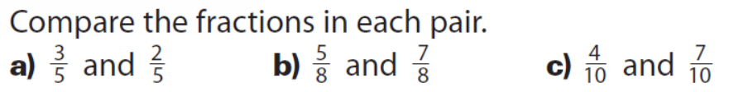
Draw a picture for each.

Place the following fractions in order from greatest to least:
1, 7, 4, 8, 6
9 9 9 9 9

