Drawing Decimal Numbers
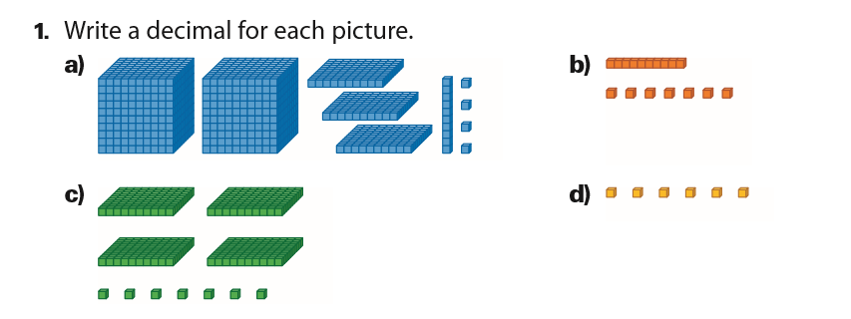
2. Draw the following decimal numbers

