Editing
Editing is an important step in writing. Even great writers edit their work (or pay someone to do it for them)! In class, we use editing tools like coloured pencils, dictionaries and word walls. Students use Rainbow Editing. This involves using different coloured pencils for the different steps in editing. Editing is meant to be MESSY! Your page should look colourful and messy! At home, using a dictionary or “Siri” is also recommended. This may take a few days as well.
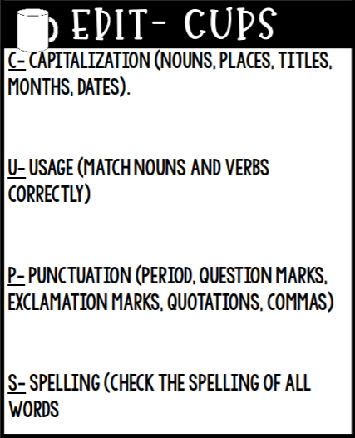
Capitalization: Choose a colour and circle the beginning letter in every word that should be capitalized. Look for the letter I, sentence beginnings and proper nouns like names of people (Alex, Tommy), specific places (New Brunswick, Saint John, McDonald’s), titles (Avengers, Little Women), and dates (Monday, July 15th). Fix anything that needs fixing.
Usage: Make sure that your verbs tenses make sense and your grammar is correct. Also, go through your writing and make sure your sentence beginnings are not all the same. Reading your writing out loud will help you figure out whether your writing sounds correct or not.
Punctuation: Select a different coloured pencil and read through your writing. Pay attention to where you are pausing. Do you need to add end punctuation or commas? Did you use more than one sentence type? Circle all your punctuation and correct as needed.
Spelling: Select another coloured pencil and underline all words that you think are misspelled. Use a dictionary or “Siri” to help you with your spelling.

Editing Checklist
Step 1  Capitalization | I used an uppercase letter at the beginnings of my sentences, for proper nouns and for the word I.
Step 2  Usage | My sentences make sense grammatically and my sentence beginnings are not all the same.
Step 3  Punctuation | I checked my punctuation and have different sentence typed in my writing.
Step 4  Spelling | I have underlined and corrected all incorrectly spelled words.

