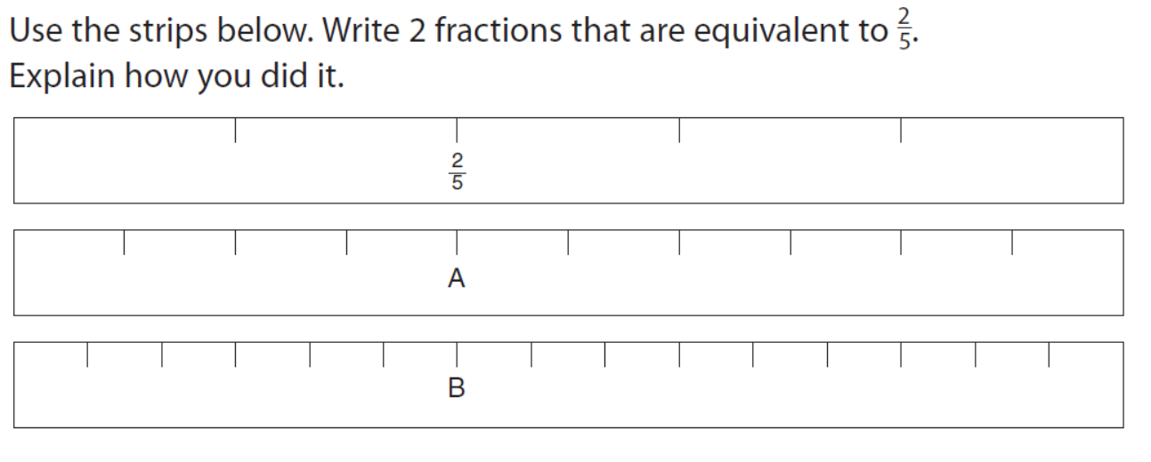
A=
B=

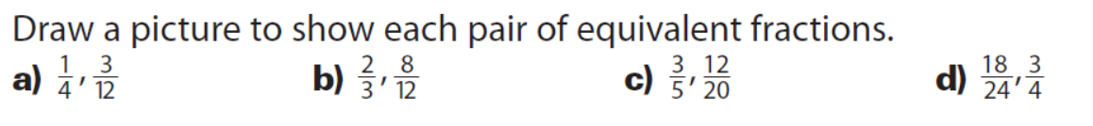
A) The first one is done for you below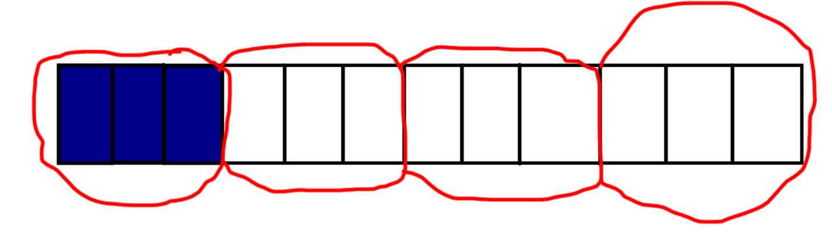
B)

C)

D)

