Videos:
https://youtu.be/N1X0vf5PUz4
https://www.youtube.com/watch?v=BiCUCqiWOlo
Games:
This game lets students build 2 equivalent fractions for a given fraction. It allows them to cut the rectangle or circle into different pieces and shows on the number line as they get closer to equivalence.
https://www.nctm.org/Classroom-Resources/Illuminations/Interactives/Equivalent-Fractions/
This is a matching game where students match the two equivalent fractions. It gives a visual as well to show that they cover the same amount of space.
http://www.sheppardsoftware.com/mathgames/fractions/memory_equivalent1.htm
This gives a visual representation as well. You have a fraction and then must find the equivalent one.
https://www.abcya.com/games/equivalent_fractions_bingo
In this game you shoot targets for the equivalent fraction. There are no visuals so you must halve, double or triple the numerator and denominator.
https://www.helpingwithmath.com/resources/games/fraction_game4/equivalent01.html
Lessons:

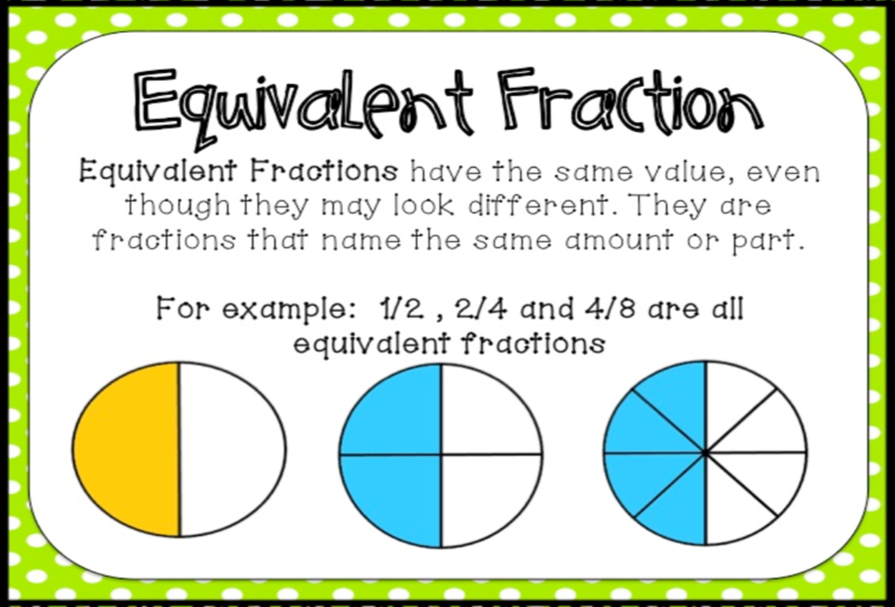
Here are some examples of equivalent fractions. You can see that the same amount is shaded, the shape is just broken into more (or less pieces). For example, you could have 2 chocolate bars that are the same size, but one is cut into 4 pieces and one is cut into 8 pieces. Eating 1 out of 4 pieces would be the same as eating 2 out of 8 pieces.
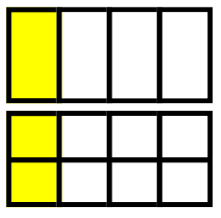
More examples:
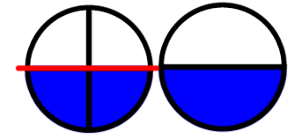
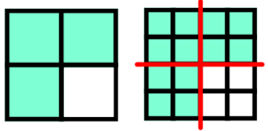
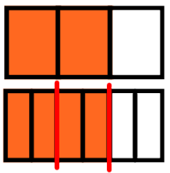

What fraction of the rectangle is yellow?
$\frac{3}{9}$

What is another way we can describe the yellow? Make less sections.
$\frac{1}{3}$

Look at the rectangle in 3 sections. How many sections are yellow?
What is another way we can describe the yellow? Make more sections.
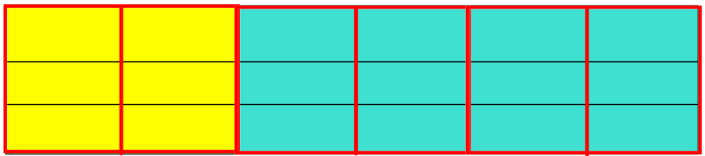
$\frac{6}{18}$

Now you try!

What fraction of the rectangle is orange?
What are two equivalent fractions? (*Think about the example above where you can break the rectangle into less pieces and then more pieces).

What fractions of the rectangle is green?
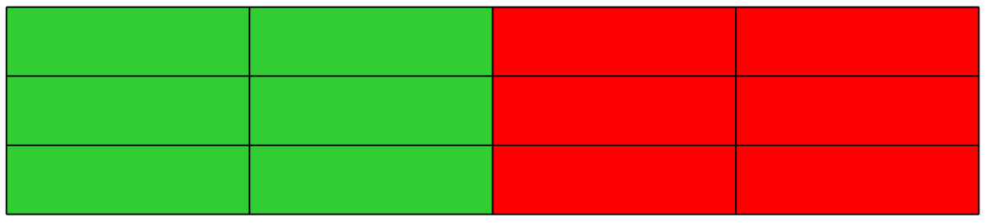
What are two equivalent fractions? (*Think about the example above where you can break the rectangle into less pieces and then more pieces).
When you’re showing how fractions are equivalent either draw 2 number lines or 2 rectangles of the exact same size, divide them into pieces according to the denominator and then colour or jump the amount of the numerator. It is extremely important that your two lines or shapes are the EXACT SAME SIZE
For example: show how $\frac{1}{4}$ and are $\frac{2}{8}$ equivalent.
Number Lines:
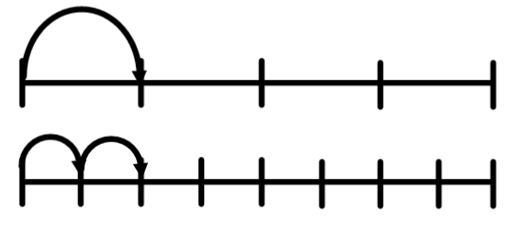
Tape Diagrams:
