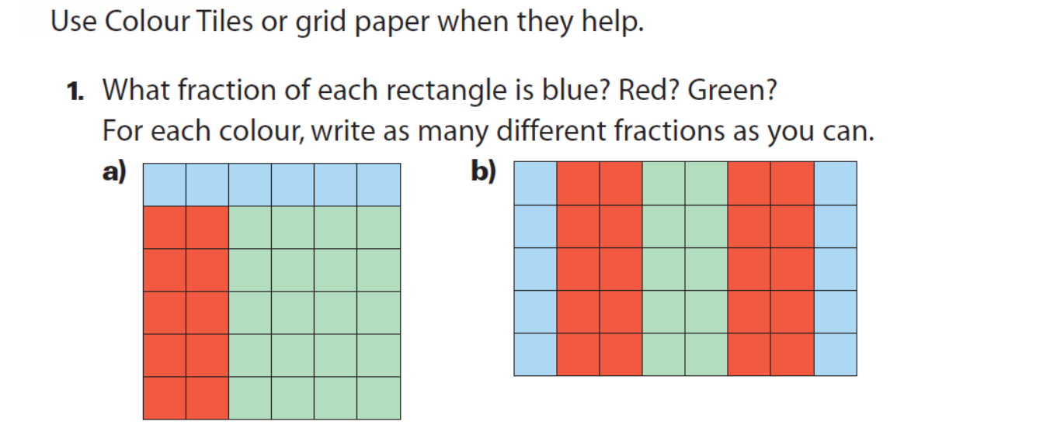
(I would like at least 2 equivalent fractions for each colour)
Colour | Fraction | Equivalent Fraction 1 | Equivalent Fraction 2
1a) Blue
1a) Red
1a) Green
1b) Blue
1b) Red
1b) Green

