ICE MELTING EXPERIMENT

ICE STEM CHALLENGE #1: WHAT MAKES ICE MELT FASTER?
In this experiment, you will investigate what makes ice melt faster, by adding several different solids to your ice.

YOU WILL NEED:
- Ice cubes
- Muffin tin, jars, or containers
- Various solids. You can start with salt and sugar, but also include different types of salt, baking soda, sand or dirt etc.
- Stopwatch or clock to determine the time of the experiment
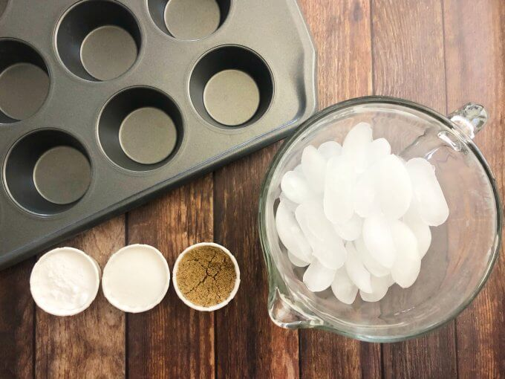

MELTING ICE SET UP:
1: Add 4-5 ice cubes to 6 cupcake cups. Make sure the same amount of ice is in each one.
2: Add 3 tablespoons of each solid to a separate container of ice.
- Add 3 tablespoons of baking soda to cup #1.
- Add 3 tablespoons of salt to cup #2.
- Add 3 tablespoons of sand to cup #3.
Cup #4, cup #5 and cup #6 are your controls and will have nothing added to the ice.
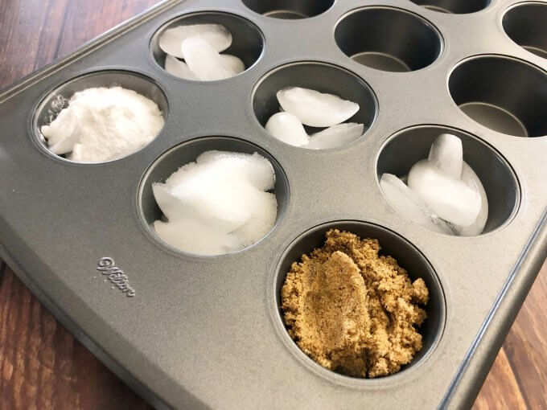
3: Set the timer to check back on the ice cubes every 10 minutes over 1/2 hour and record your results. Then draw your conclusions.
What caused the ice to melt fastest?
EXTENSION: Use a timer and record how long it took each material to melt the ice. Record the results. Try adding solids of your own choice and record that data too. Now, turn the data into a graph!

