Revising
When revising, it is beneficial to read your writing out loud in order to hear what it sounds like. Below is an acronym we started using in the classroom to help revise our work. You should go through your writing 4 times, making sure you do each step. This may take more than one day. Revising differs from editing in that it is still working on content. We want to improve on the way our writing sounds, making sure that we have added enough details and interesting words in order to create a strong piece of writing. I would recommend reading your writing out loud before your revise, and after you finish.
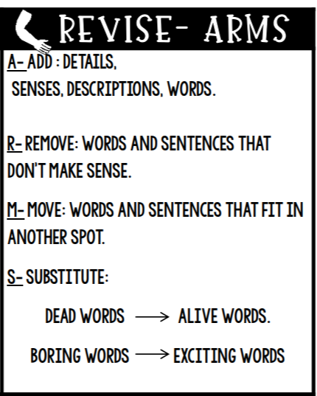
Revision Checklist:
Step 1  Add | I added details and descriptive words.  (ie: Starting paragraphs with a hook, explaining my ideas by adding more details)
Step 2  Remove | I crossed out or changed sentences and words that did not make sense.
Step 3  Move | I moved words and sentences around so that my writing flowed.
Step 4  Substitute | I substituted boring words for exciting/ million dollar words

